

Using Loops in Manifest
DevOps Certification Training

support@intellipaat.com
+91-7022374614
US: 1-800-216-8930(Toll Free)

USING LOOPS IN MANIFESTS
ONLYIF
Steps for Puppet Master

Step 1: Change the directory to /etc/puppet/code/environments/production/manifests
$ cd /etc/puppet/code/environments/production/manifests
$ sudo nano site.pp

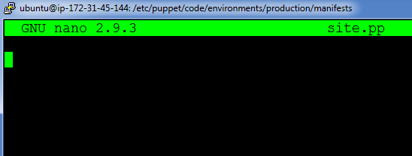

Step 2: Enter the following text:
node default{
$packages=> [‘apache2’,’mysql-server’]
package{$packages:
ensure=> installed,
}
}

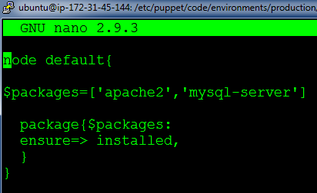

On Puppet Agent
Step 1: Execute the following command:
$ sudo puppet agent --test

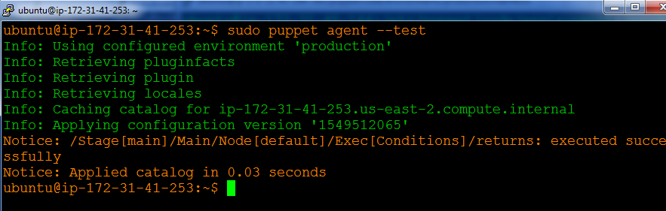

Step 2: Verify the installation by going to the browser with Agent’s IP address and mysql service status
